List of Equipment Requested and Corresponding Estimated Budgetary Requirements
Equipment | Photo | Quantity | Total Cost | Justification/Use of Equipment
Analytical Balance | 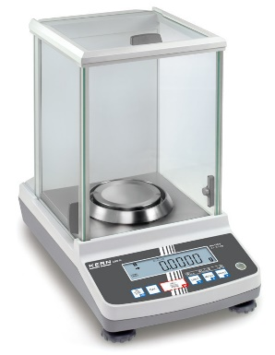 | 1 unit | 150,000 | To be used in measuring minute amounts of solid reagents.
Eppendorf micropipette set | 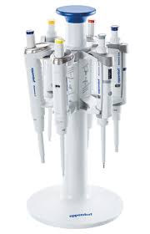 | 1 set | 70,000 | To be used for reagent and media preparation, DNA extraction analysis and microbial assays.
Laminar Hood/ Biosafety Cabinet Level II | 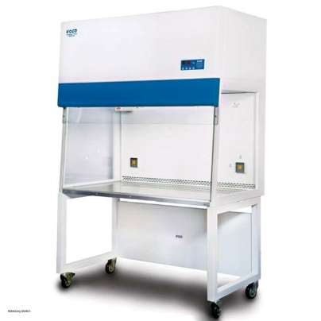 | 1 unit | 300,000 | Core equipment for microbiology research to be used for aseptic isolation and culturing of microbial samples of nonpathogenic microorganisms.
Laminar Hood/ Biosafety Cabinet Level III | 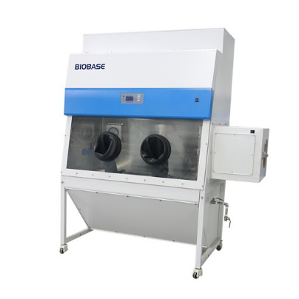 | 1 unit | 500,000 | Core equipment for microbiology research to be used for aseptic isolation and culturing of microbial samples of pathogenic microorganisms.
Laboratory Grade Refrigerator | 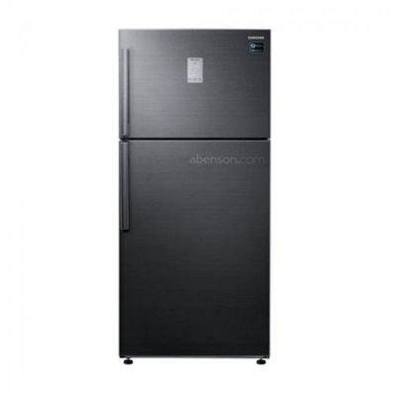 | 2 unit | 200,000 | To be used for storage and keeping of samples. One refrigerator will be used for the storage of prepared/ unused culture media, and the other will be used for storage of cultured medias.
Hot plate with magnetic stirrer | 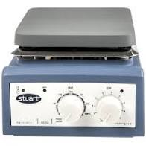 | 1 unit | 50,000 | A magnetic stirrer is a device that consists of a rotating magnet or a stationary electromagnet that creates a rotating magnetic field. This device is used to make a stir bar, immerse in a liquid, quickly spin, or stirring or mixing a solution, for example.
Desktop pH meter and water activity meter | 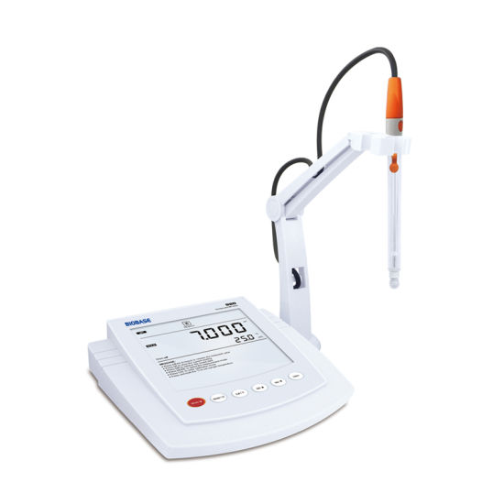 | 1 unit | 60,000 | To be used for determining pH and water activity of samples.
Incubator | 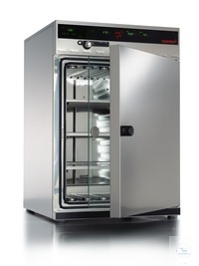 | 2 units | 400,000 | Essential equipment to be used for incubation of microbial samples. Two units is needed to have a separate incubator for microorganisms needing different temperatures (28° and 37°).
Anaerobic Jar | 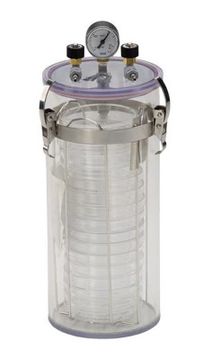 | 1 unit | 70,000 | Essential equipment to be used for incubation of anaerobic samples.
Refrigerated Microcentrifuge | 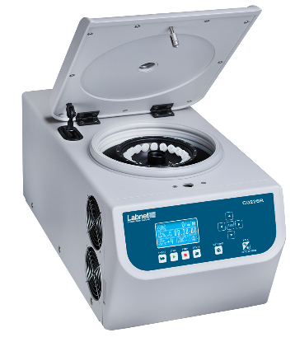 | 1 unit | 100,000 | Essential equipment for microbiology work; to be used for analysis of samples.
Top loading Autoclave/ Sterilizer | 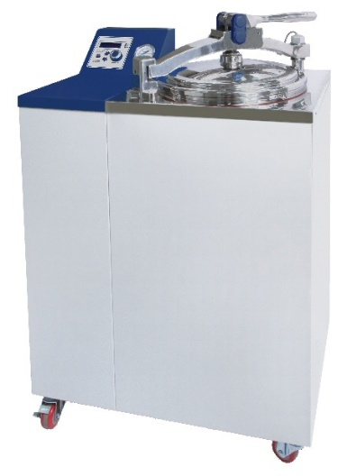 | 2 unit | 800,000 | Essential equipment in a microbiology/molecular biology laboratory for preparation of materials, media and reagents. One will be used for sterilization and the other one for decontamination.
Vortex mixer | 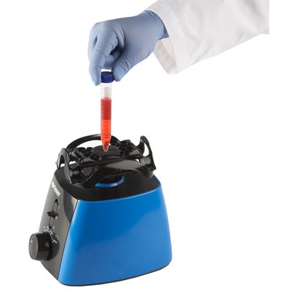 | 1 unit | 60,000 | Essential for microbiology work; to be used in processing of samples.
Incubator shaker | 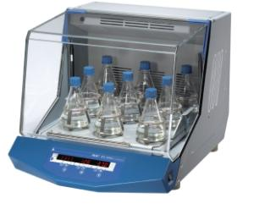 | 1 unit | 300,000 | Essential equipment to be used for incubation of microbial samples under aerated conditions
UV-vis Spectrophotometer set with desktop and built-in UPS with AVR | 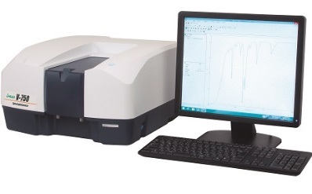 | 1 unit | 700,000 | Spectrophotometers measure light intensity as a function of wavelength and are commonly used to measure the concentration of a compound in an aqueous solution. Depending on the type of spectrophotometer, different wavelengths of light can be analyzed.
Thermal cycler and accessories | 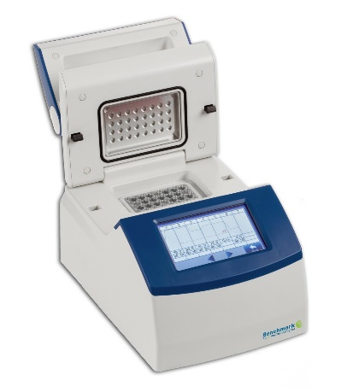 | 1 unit | 500,000 | Essential equipment for molecular biology work with PCR amplification of DNA, important for Kurakding taxonomy.
Gel- documentation | 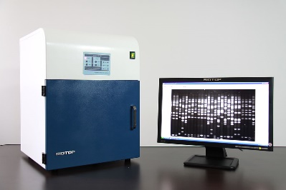 | 1 unit | 500,000 | Core equipment needed for molecular biology work and will be used in viewing gels from PCR reactions and DNA extractions of Kurakding samples.
Mini-gel electrophoresis system | 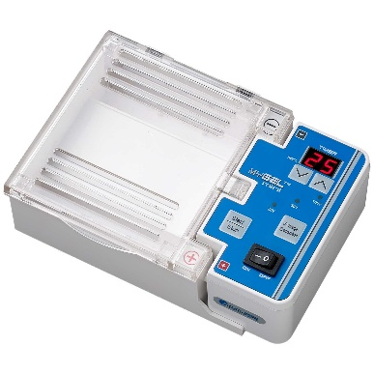 | 1 unit | 150,000 | Essential equipment for molecular biology work to be used for analysis of extracted DNA samples of Kurakding.
Total |  |  | 4,910,000.00

